# **ASSIGNMENT COVER PAGE**



**J.E. CAIRNES SCHOOL OF BUSINESS & ECONOMICS**

**GROUP ASSIGNMENT**

**Module Name and Code: Enterprise Systems – MS809**

|  |  |
| --- | --- |
| **Student Name** | **Student ID** |
| Dilip Venkatesan Sankar | 22225743 |
| Alan Melvin Albon | 22222163 |
| Nithin Frank Francis | 22222388 |
| Hemanth Kumar Ravilla | 22223108 |
| Swathi Babu | 22210391 |

**Declaration for this Assignment Submission*:***

*In submitting this work, we confirm that it is entirely our own. We acknowledge that we may be invited to interview if there is any concern in relation to the integrity, and we are aware that any breach will be subject to the University's Procedures for dealing with plagiarism (*[*http://www.nuigalway.ie/plagiarism*](http://www.nuigalway.ie/plagiarism) *).*

**Table of Contents**

1. Introduction…………………………………………………………………………………3
2. Business Objective………………………………………………………………………….3
3. Major problems with the current process…………………………………………………...3
4. Recommended changes……………………………………………………………………..4

4.1 Overview…………………………………………………………………………… …..4

4.2 Re-engineered model for loan application and approval………………………………..6

4.3 Re-engineered model for payment, settlement, and delinquency……………………….8

5. Performance Metrics………………………………………………………………………...9

## **1. Introduction:**

The Reliable Finance Company has been in operation since the 1890s and currently has 178 branches. RFC operates differently from commercial banks, taking on risks and charging a little bit more in interest. Ed Clarkson, who currently oversees the business, has set a goal to increase the number of branches to 400 and 1000 in the following three and five years, respectively, throughout all regions. In order to accomplish the objective, enhancing and re-designing the existing information system and consumer loan system is required.

## **2. Business Objective:**

In order to achieve the goal proposed by Ed Clarkson we are looking into streamlining, modifying, and enhancing the existing process, and below are the objectives of the project,

1. To provide the highest standards of integrity and reliability by improving the loan approval rates and retaining prospects with higher credit risks.
2. To increase the competitive advantage compared to the commercial banks by proposing a new loan approval system.
3. Utilize data and predictive analysis to predict potential delinquency for profile building.
4. Develop a payment gateway to automatically process recurring payments to avoid clerical issues.
5. To aid in the organization's strategies for growth.
6. Introducing a database management system to rule out manual work and facilitate process improvement.

## **3. Main problems with the current process:**

RFC currently has 178 locations around the United States, from Denver to Cleveland and from Detroit to Houston. And because RFC is losing valuable time to manual work and laborious processes, significant improvements must be made in order to enable the expansion without causing any financial damage to the organization. Most crucially, RFC experiences problems with data loss, error correction, and clerical duties as a result of the lack of a centralized data storage system.

1. The current process for sanctioning loans can take up to 10–13 working days because there is a lot of human labor and physical transportation of files, which significantly slows down the process and leads to the loss of potential loan prospects.
2. There have been various errors and data losses as a result of the manual loan and payment processing, which necessitates traceback, clerical work, and error fixes.
3. The corporation finds it challenging to manage payments, identify delinquents, and conduct consumer profiling, which resulted in 2.5% of unpaid loans.
4. Another serious issue with processing payments is that there may be a delay in updating the files for outstanding loans because the Delinquency Report is only generated once a week, which results in the customer receiving a reminder email. This causes customer dissatisfaction and increases salary costs because more staff are needed to handle customer calls and an increased manual process.
5. It is particularly difficult to manage the month-end balance sheet, which results in irregular cash flow and higher interest rates due to an increase in error corrections, additional clerical work, and delayed payments.

## **4. Recommended Changes:**

**4.1 Overview**

We have proposed to have a **Loan Approval Process** (LAP) in place to support these improvements after re-engineering the loan application and approval process to solve the aforementioned issues. Additionally, we advise implementing a **Record Management System** (RMS) to ensure the dependability of the loan settlement, delinquency management, and payment processes. Additionally, the databases of these two LAP and RMS will securely retain the data and provide prompt reporting and forecasting.

In order to further shorten the time, it takes for approval, we have also proposed the below,

**1. Reliable Finance Online Banking (RFOB) portal**, where clients would be given the option to apply for loans online. These suggestions may also be a way to move customers online.

**2. Quota-based loan,** which gives the power to the Branch Manager to approve and sanction the loan directly if the asked amount is within the allotted range following conditions.

We also suggest a framework (as shown below) for organizing a team on a project to feed in the old and existing loan details into the system concurrently with partially migrating the customers online to feed directly into the database system (RMS).

According to the updated structure, RFC will have a single main office, under which four regional clusters will report. Numerous branches from each cluster will report to them in their respective regions. The initial point of contact for customers will continue to be branches. Branch Managers (BMs) will oversee each branch, while Administrative Assistants (AAs) and Customer Service Representatives (SRs) will work under them. This structure will control the entire loan application and approval procedure. In the next section, we further clarify the altered procedure in light of the new organizational structure.

***Fig 1: Overall updated Structure for RFC***

**4.2 Re-engineered model for loan application and approval**

Based on the conditions given, the existing model has been re-engineered in order to provide maximum benefit to the company. The diagram and the process have been explained below,

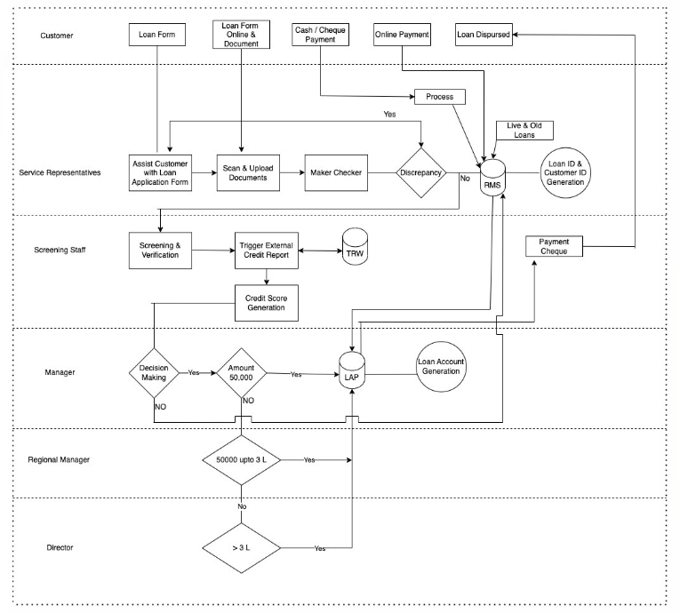

* Customers will approach their neighborhood RFC branch and work with Service Representatives to complete the application process. They will also submit the required paperwork with the application.
* The customer may also do the same process online and upload the necessary documents.
* The services that the SRs offers at the branch are,

- Assist with the loan application

- Maker or Checker role

- Project staff: Upload information on current and past loans in RMS

Furthermore, SR will input the customer's information into the RMS, and a special Loan Application Id will be generated.

* The relevant loan forms will be returned to the origin if there are any discrepancies found during the maker checker process; otherwise, the forms will be imported into the RMS and a unique loan ID and Customer ID will be generated.
* The RMS will be updated with the specifics of both live and old loans in the meantime by project employees.
* The screening staff will conduct the screening and other RMS-based verification. Additionally, they will trigger an external credit report to export credit scores from TRW and then produce a credit score report and profile for the manager to review before making a choice.
* An approval process is followed here by the manager, with the help of the credit score report and profile generated. If approved, the amount of approval is then examined as the next step.
* If the loan amount is less than 50000 (< 50000), the manager takes a call and once approved it is sent to LAP.
* If the loan amount exceeds the allowed amount (50000 in our case), it is forwarded to the Regional Manager (50000 up to 3L) or the Director (>3L), accordingly.
* The loan would be approved by a manager or director, who would then transmit it to LAP, which creates a special loan account number.
* The loan information will be sent into the RMS if the Manager rejects the loan.
* LAP completes the loan approval process and prints a check that is presented to the customer by screening employees.
* If the client pays the loan online, the RMS will be updated immediately; if the customer pays with cash or a check, the SRs will update the RMS after the payment is made.

If the loan is applied online and the limit is under 50,000, this approach will reduce the processing time for loan approval from 10 to 13 days to 1 day, or a maximum of 3 days depending on the amount and mode. To ensure that the consumer stays interested in our company, we will send him automated updates as the case advances through each phase.

**4.3 Re-engineered model for payment, settlement, and delinquency**

It is the company's responsibility to build the payment system in a user-friendly manner with fixed criteria after the loan has been approved and sanctioned in order to prevent complications with settlement and delinquency. The necessary improvements and recommendations are listed below,

1. Update the central database based on information about client payments paid through cash, check, or money order as opposed to manually updating the loan files that are still open and mailing the APR to the home office or branch. By implementing this procedure, manual labor hours, file loss, and incorrect entries can all be avoided.

2. Depending on the need, delinquency, and loan settlement reports are generated for each client account on a daily, weekly, and as-needed basis.

3. Introducing fixed installment rates like the 1st,10th, and 15th of each month depending on customer preference and fixing auto-debit sequence to their accounts.

4. To make sure the customer doesn't forget to make the re-payment, multiple reminder emails or SMS messages are sent to the relevant customer two days and one day before the due payment, and on the day of due payment as well.

5. Automated email/SMS generation to customers if they do not maintain a minimum balance during the loan repayment period.

6. Automated email/SMS is generated to the customer in case of a miss in loan re-payment. And with the help of the central database, a ticket, and a customer payment details report are generated and assigned to a resource to follow up on the same day.

7. The central database is updated each month after the payment cycle to maintain historical data about the customer which is maintained by the ops team to build a customer profile.

8. The central database helps in following up and tracking missed payments, which also keeps the branch manager and home office about the ongoing activities.

9. Decreased manual intervention, timely generation of balance sheets, and increased cash flow due to timely updating of the database.

## **5. Performance Metrics**

1. The duration of LAP can be **shortened to 2 to 3 days** by using the suggested restructured method, drawing in more clients, and generating more income.

2. Customers do not need to contact the company for incorrect payment reminders, even though it has paid off - **Less manual work**, which can be used in other ways, and an increase in RFC's trust and dependability.

3. The "uncollectible amount" that causes a loss to the organization can be recognized by carefully tracking payments with the **new process and centralized database**, leading to an increase in income.

4. **Performance, efficiency, and scalability** improvements enable the growth of RFC.

5. With the introduction of SMS/Email reminders, timely loan repayment assures a **correct balance sheet and lowers missed payments and delinquencies**.

6. With the TRW credit score data, which aids in **customer profiling**, the operations team may identify and group delinquent clients and potential clients respectively.

7. When loan payments are timely and promptly updated in the central database by both the branch and the home office, there is no need for **error correction or additional clerical work**, ensuring resource efficiency, time savings, and productivity are all increased.